SQL Finale Project Explanations:

By: William V. Fullerton

**Base Queries:**

**1: Created Tables:**

How can we make a database in SQL for a video game company?

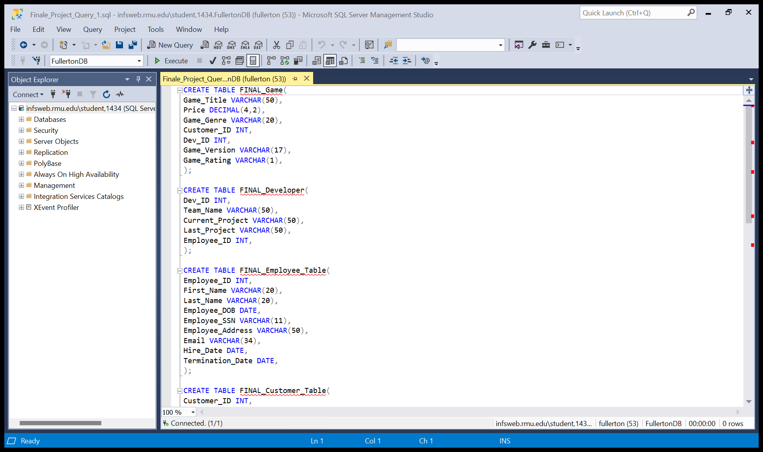

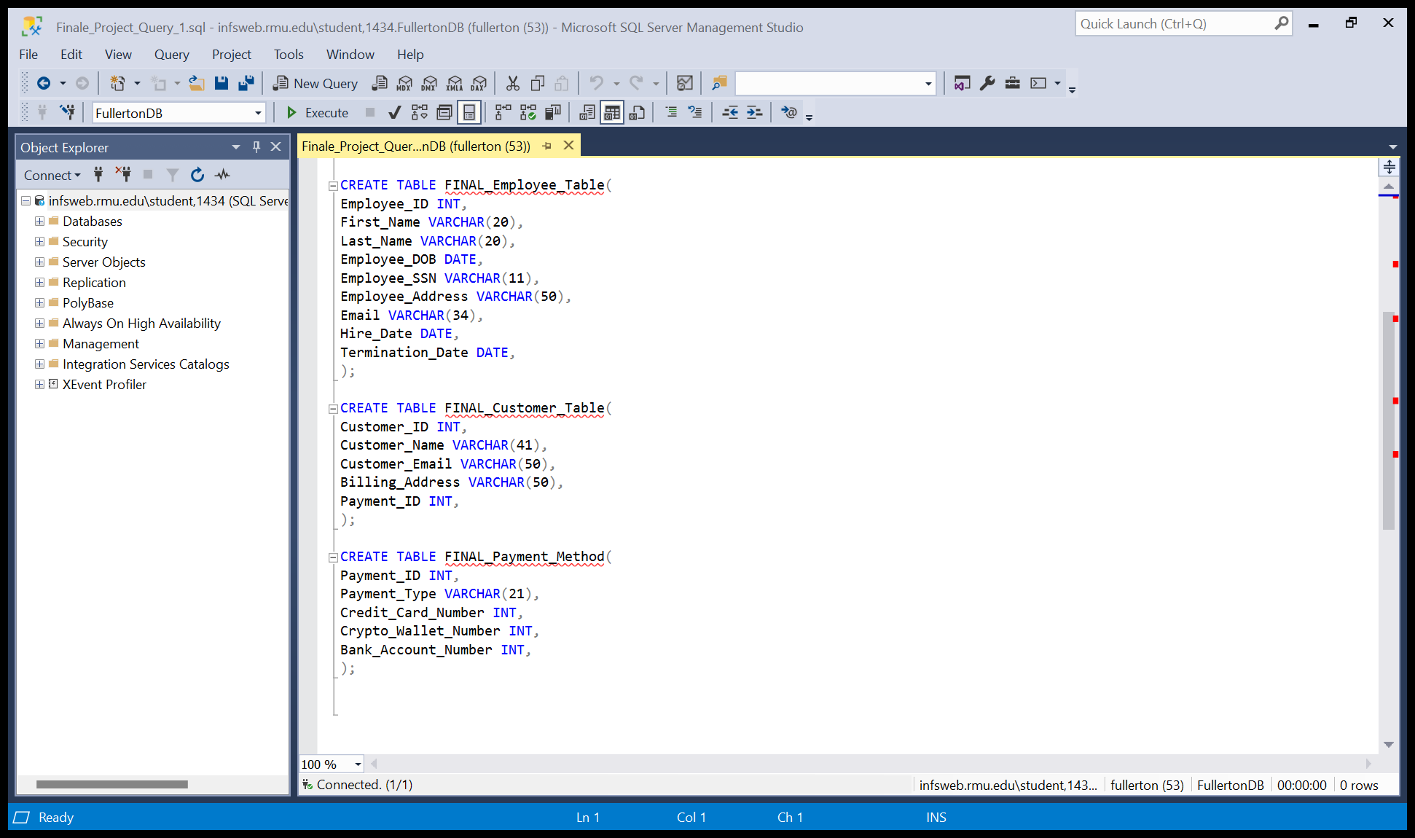

This query created all five tables necessary for the data to be inserted into them, with all fields having their proper types.

**2: Update Query:**

Raise the price of Science Fiction games by five percent.

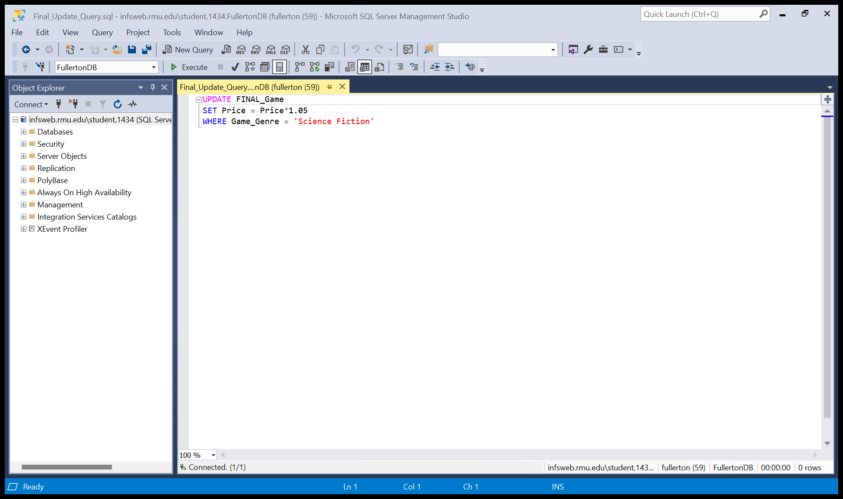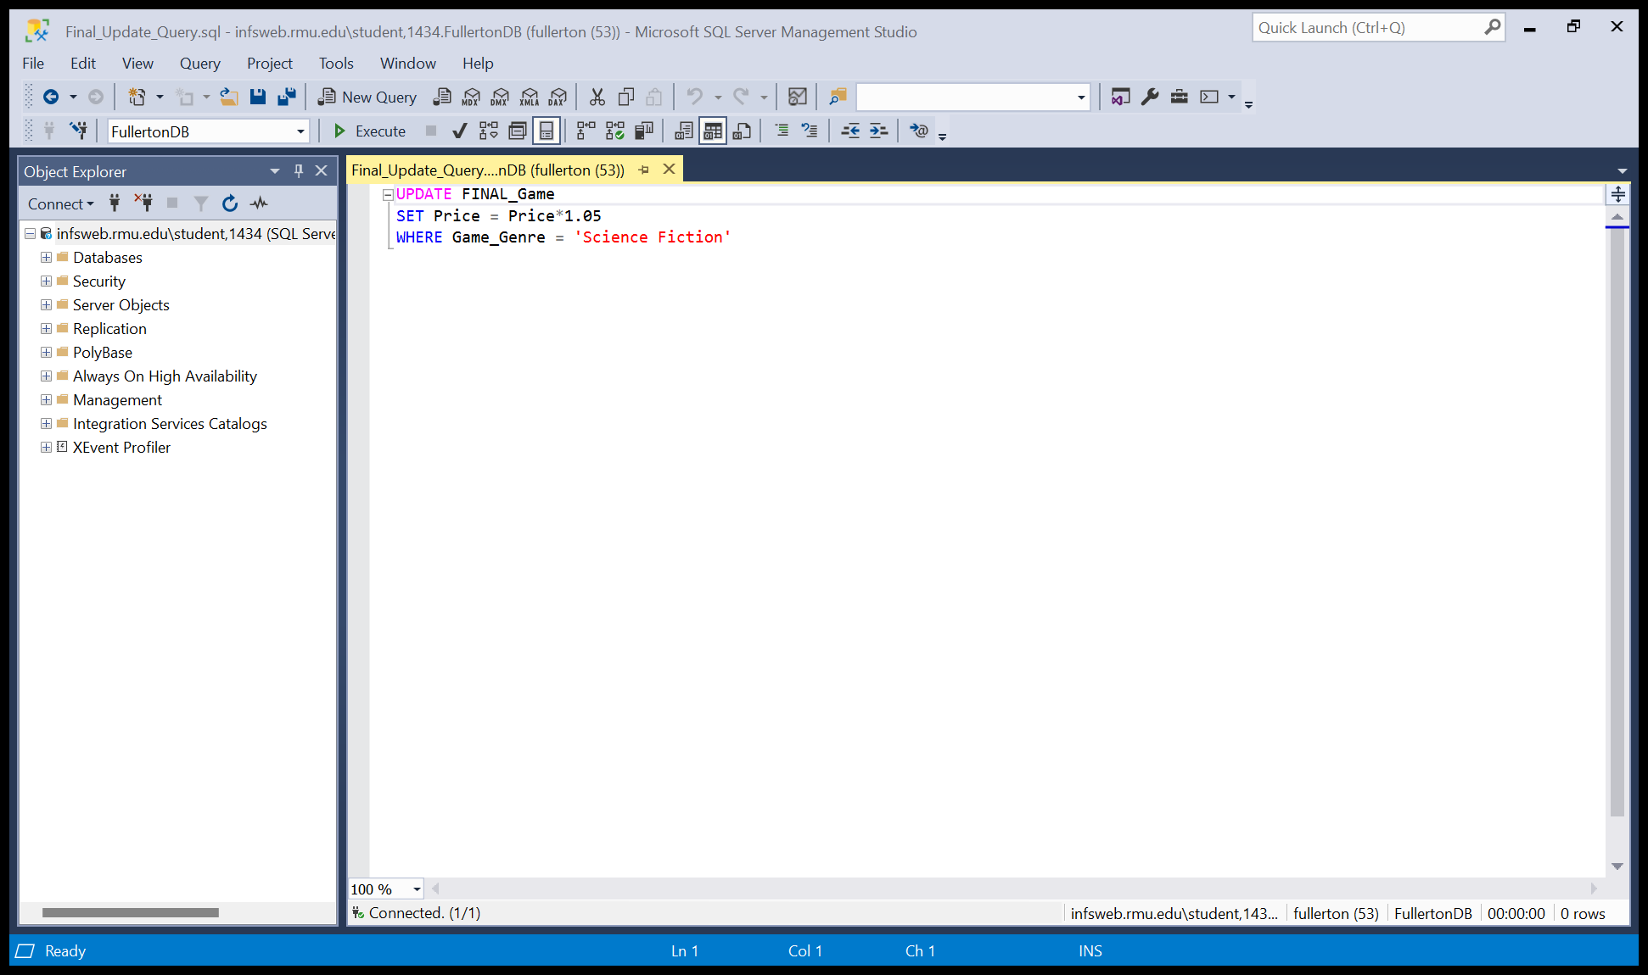

This query updated the price of all science fiction games by five percent.

**3:**  **Select with a where statement:**

What is the price of all games released after 2009?

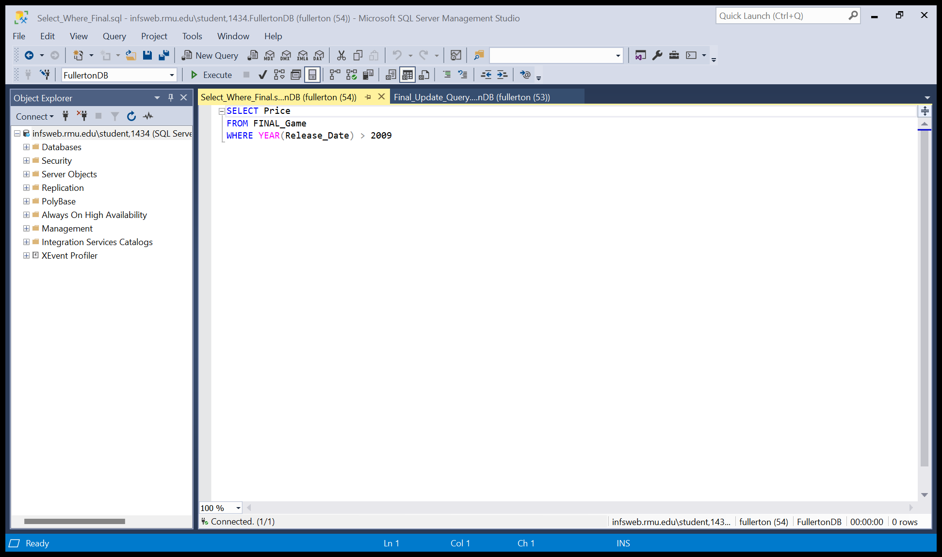

This query showed the price of all games released after the year 2009.

**4: Mask Query:**

Do all email addresses begin with the same letter as the persons first name, for employees?

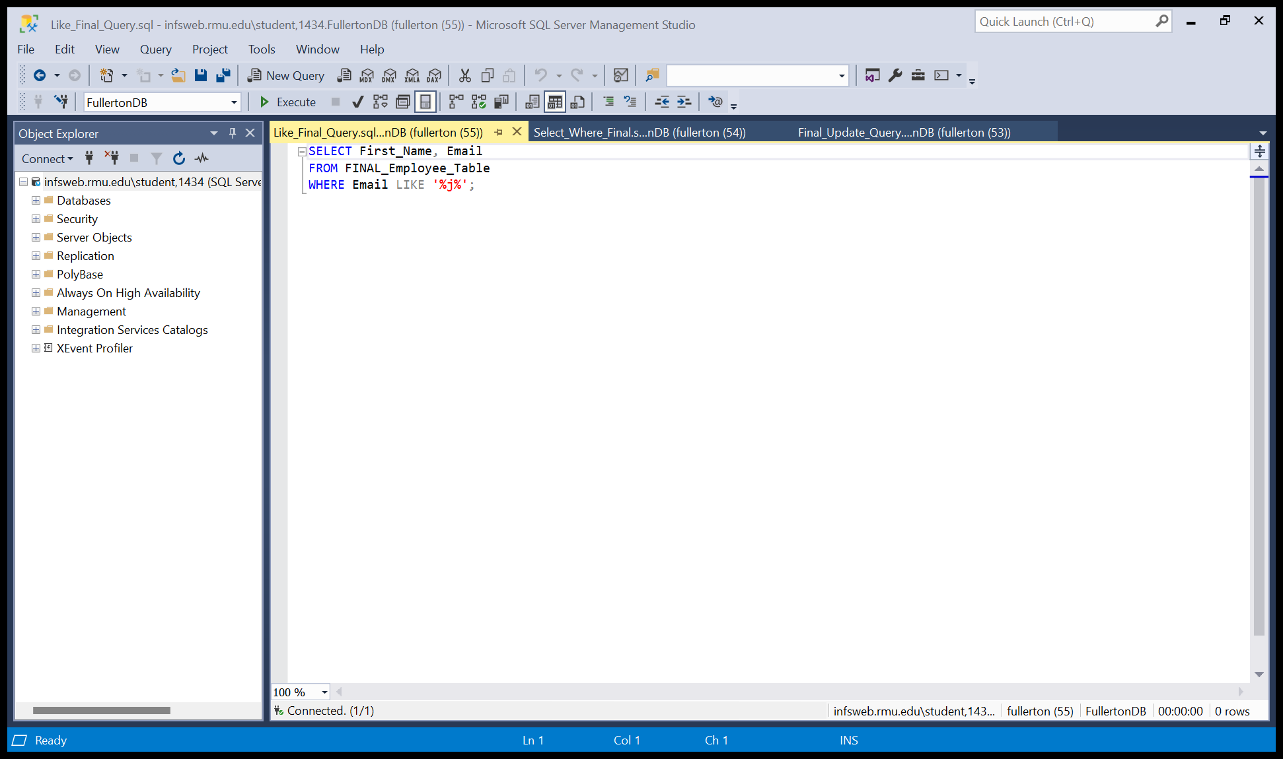

This query selected a sample size, where the first letter of everyone’s first name starts with a J, and checked it against their email, and all four records where in fact correct.

**5: Order By:**

When have all of our games been released in relation to time?

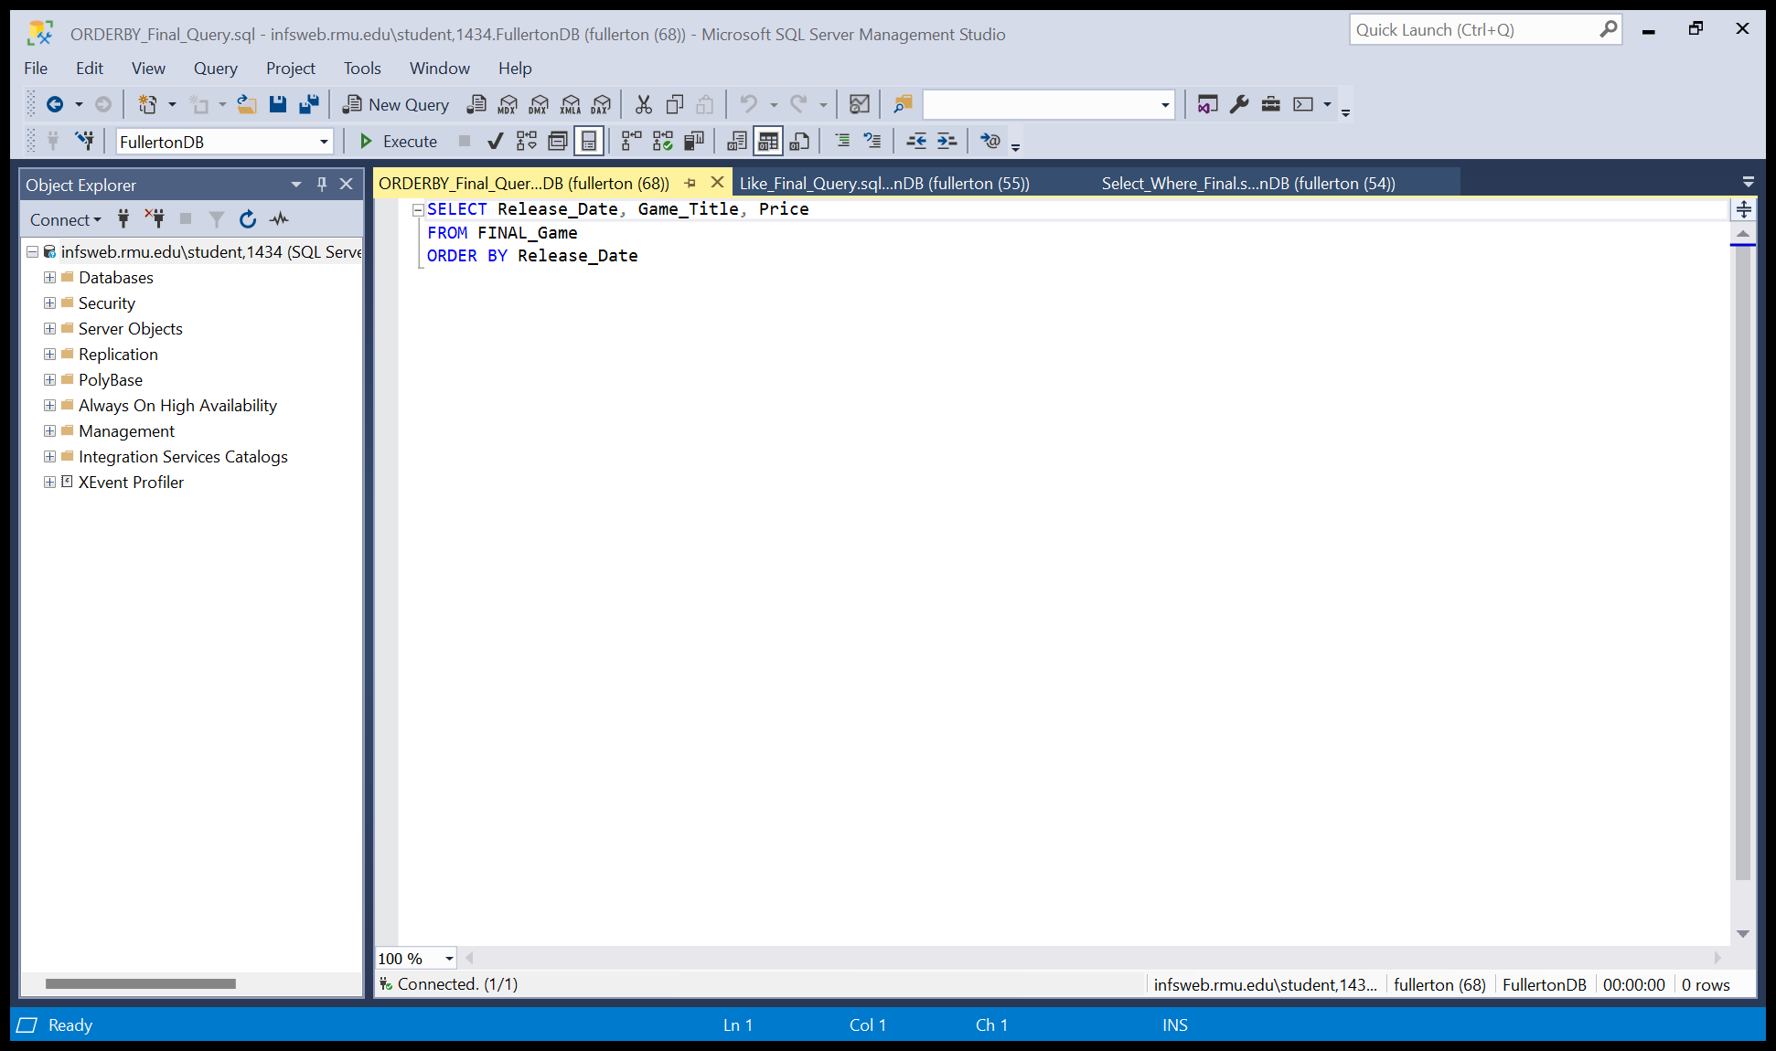

This query selected the release date, game title, and the price from the game table and had them arranged or ordered by their chronological release date.

**6: Aggregate Query:**

We want to know what the average price of our games sold under the “Philosophy” genre are, as the higher ups don’t believe that they are a good seller, despite their great public reception?

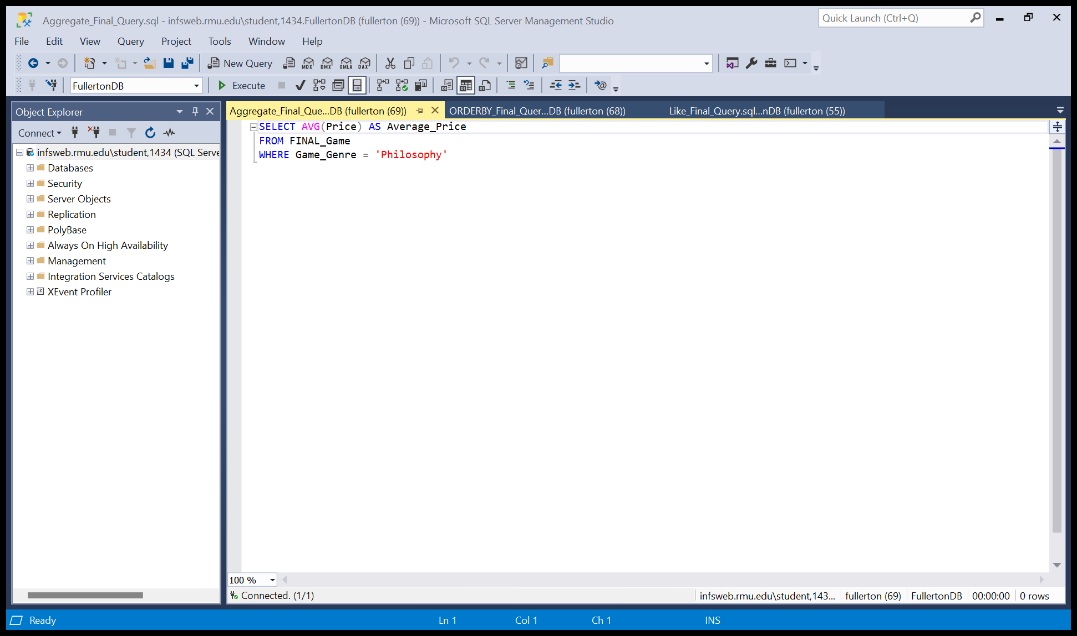

This query too the average price where the game had a genre of philosophy.

**7: Group By:**

How many people are working on each project on each team?

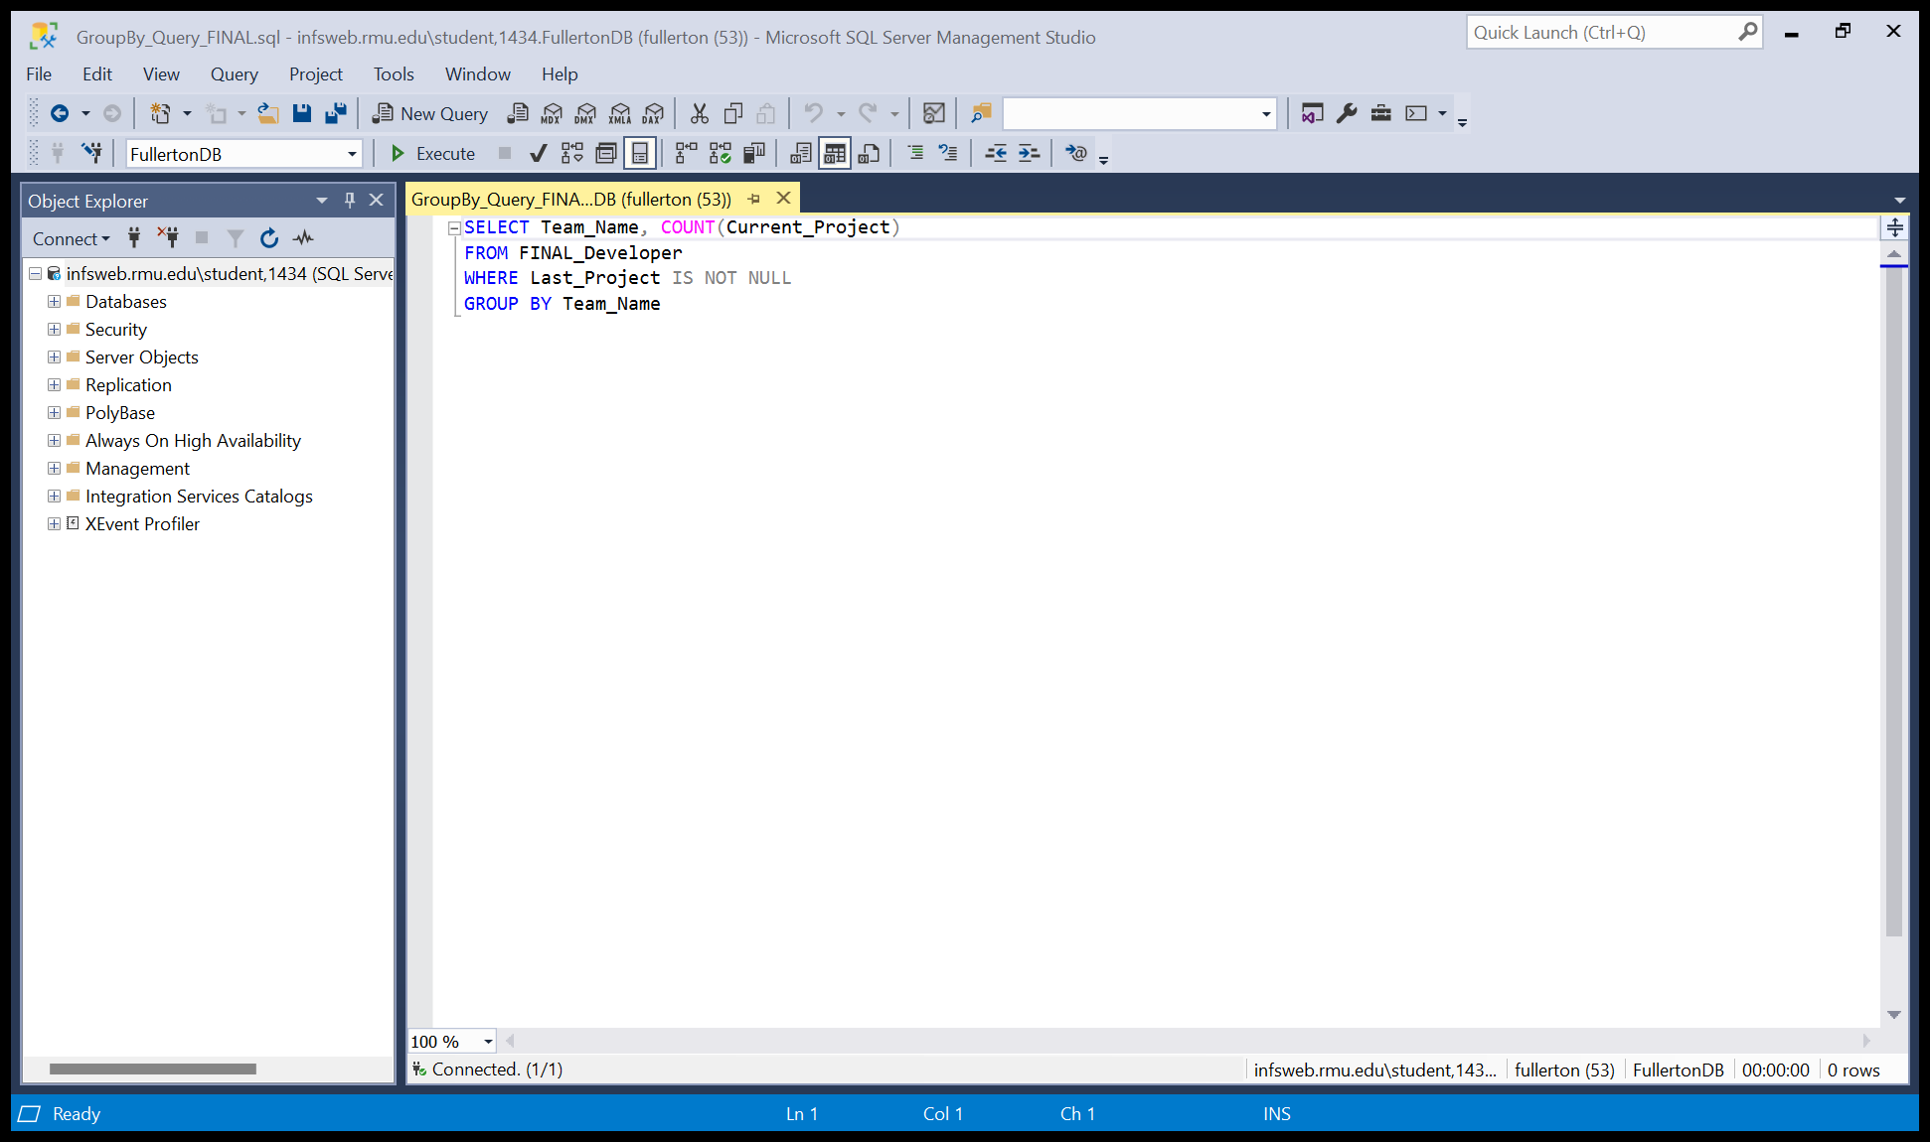

This query selected the team’s name as well as the number of current projects for that team, and grouping it by the team’s name, where the employee has had a prior project. I.E. the developers are not brand-new employees.

**8: Calculated Field:**

What is the total of all game prices released during each year where we have released a game?

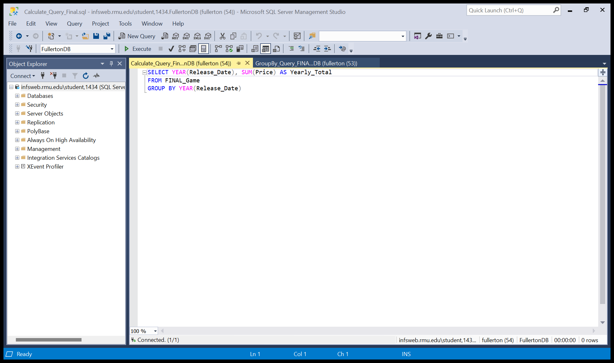

This query selected the year and the total of all prices from game table and grouped them by year to show the relevant data.

**9: Group By/ Having:**

Is it true that the number of credit cards users exceeds the number of all other types of payment, individually?

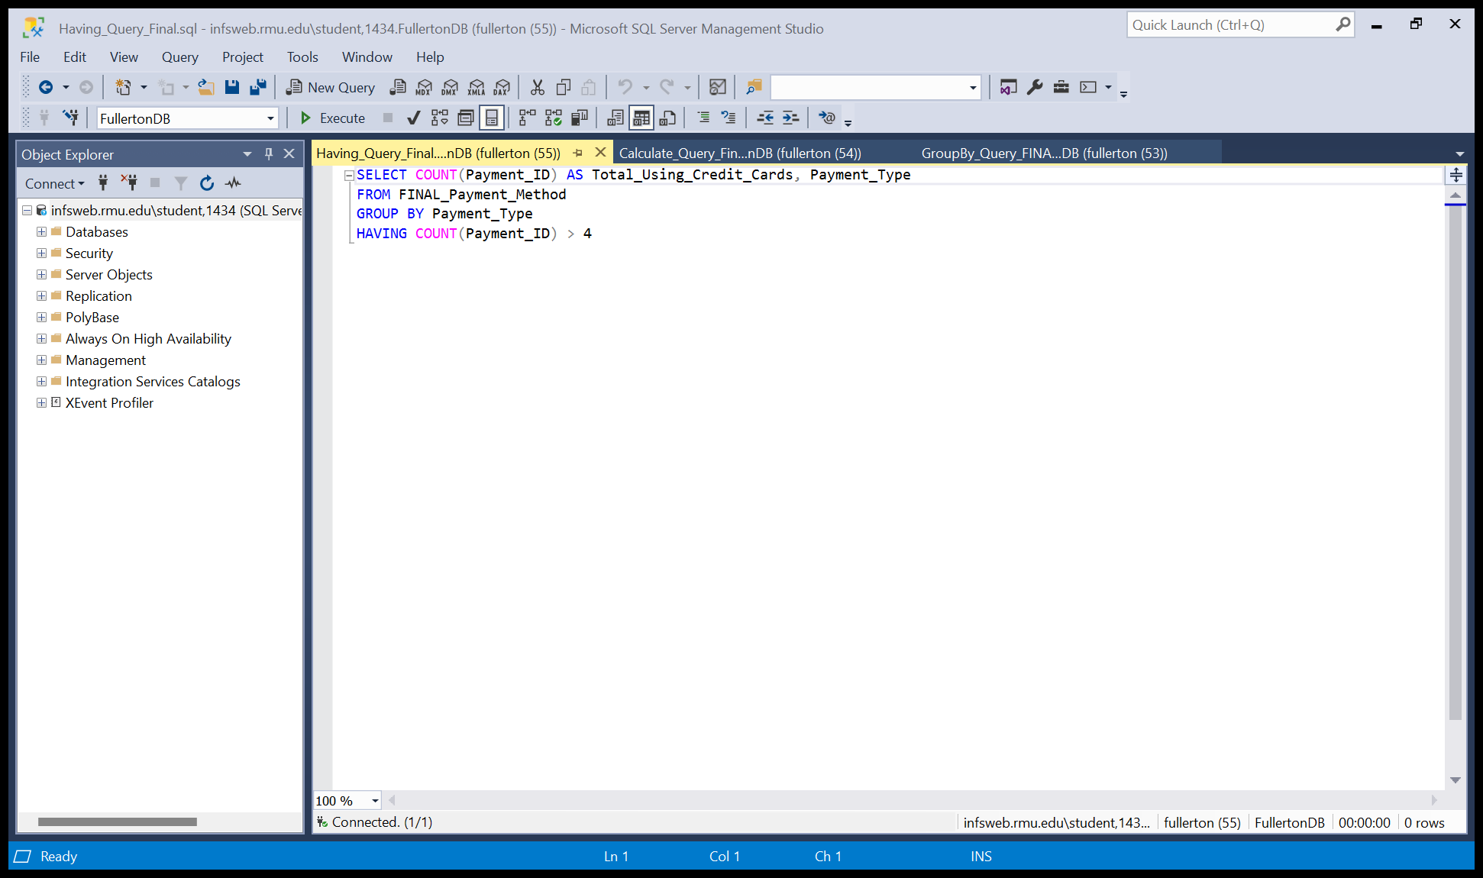

This query looks at the number of payment ids, grouped by their type, where there are more than four of the same payment id.

**10: Subquery:**

Which game genres should be making us the most money or are over priced, based upon their price?

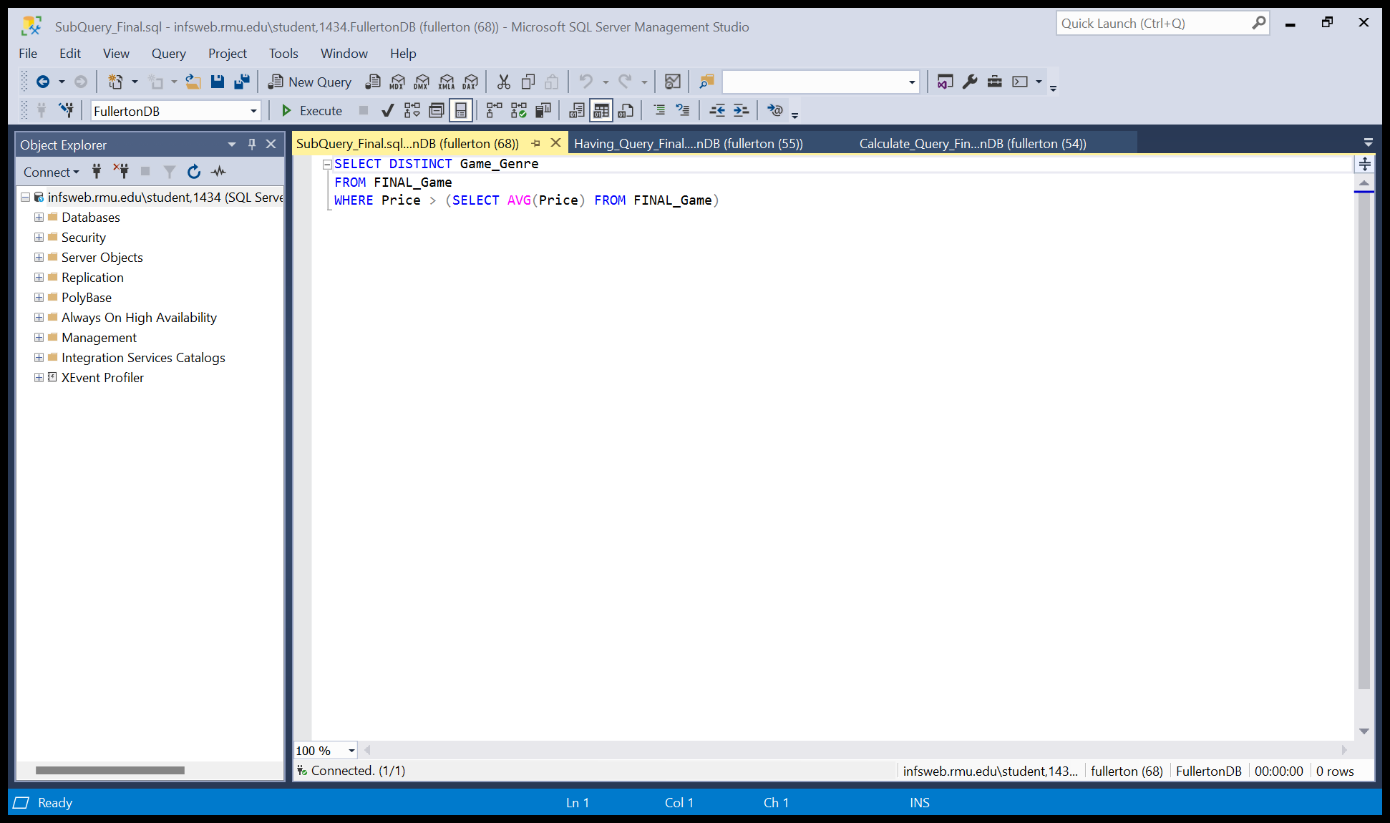

This query took the distinct game genres and found which one(s) had a price greater than the average price of all games.

**Views:**

**Views 1:**

Create a small view to see how many employees have been terminated and who they are.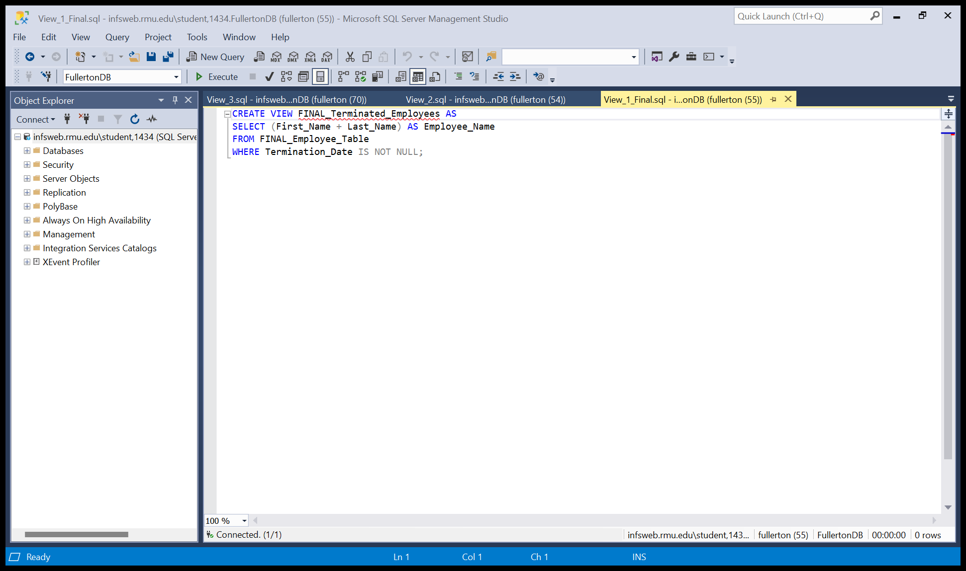

**View 2:**

We would like to see how many of our customers used a crypto currency to pay for our games.

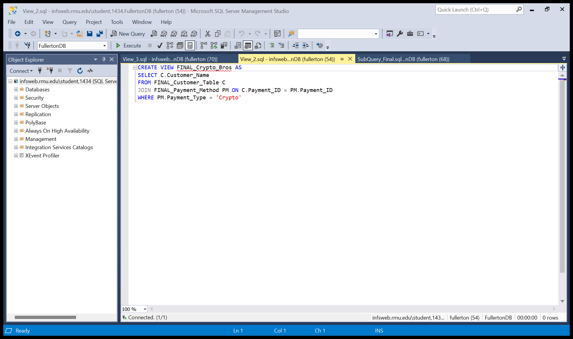

**View 3:**

We wanted to see how many of our employees have not been with the company for very long or have never been on a past project.

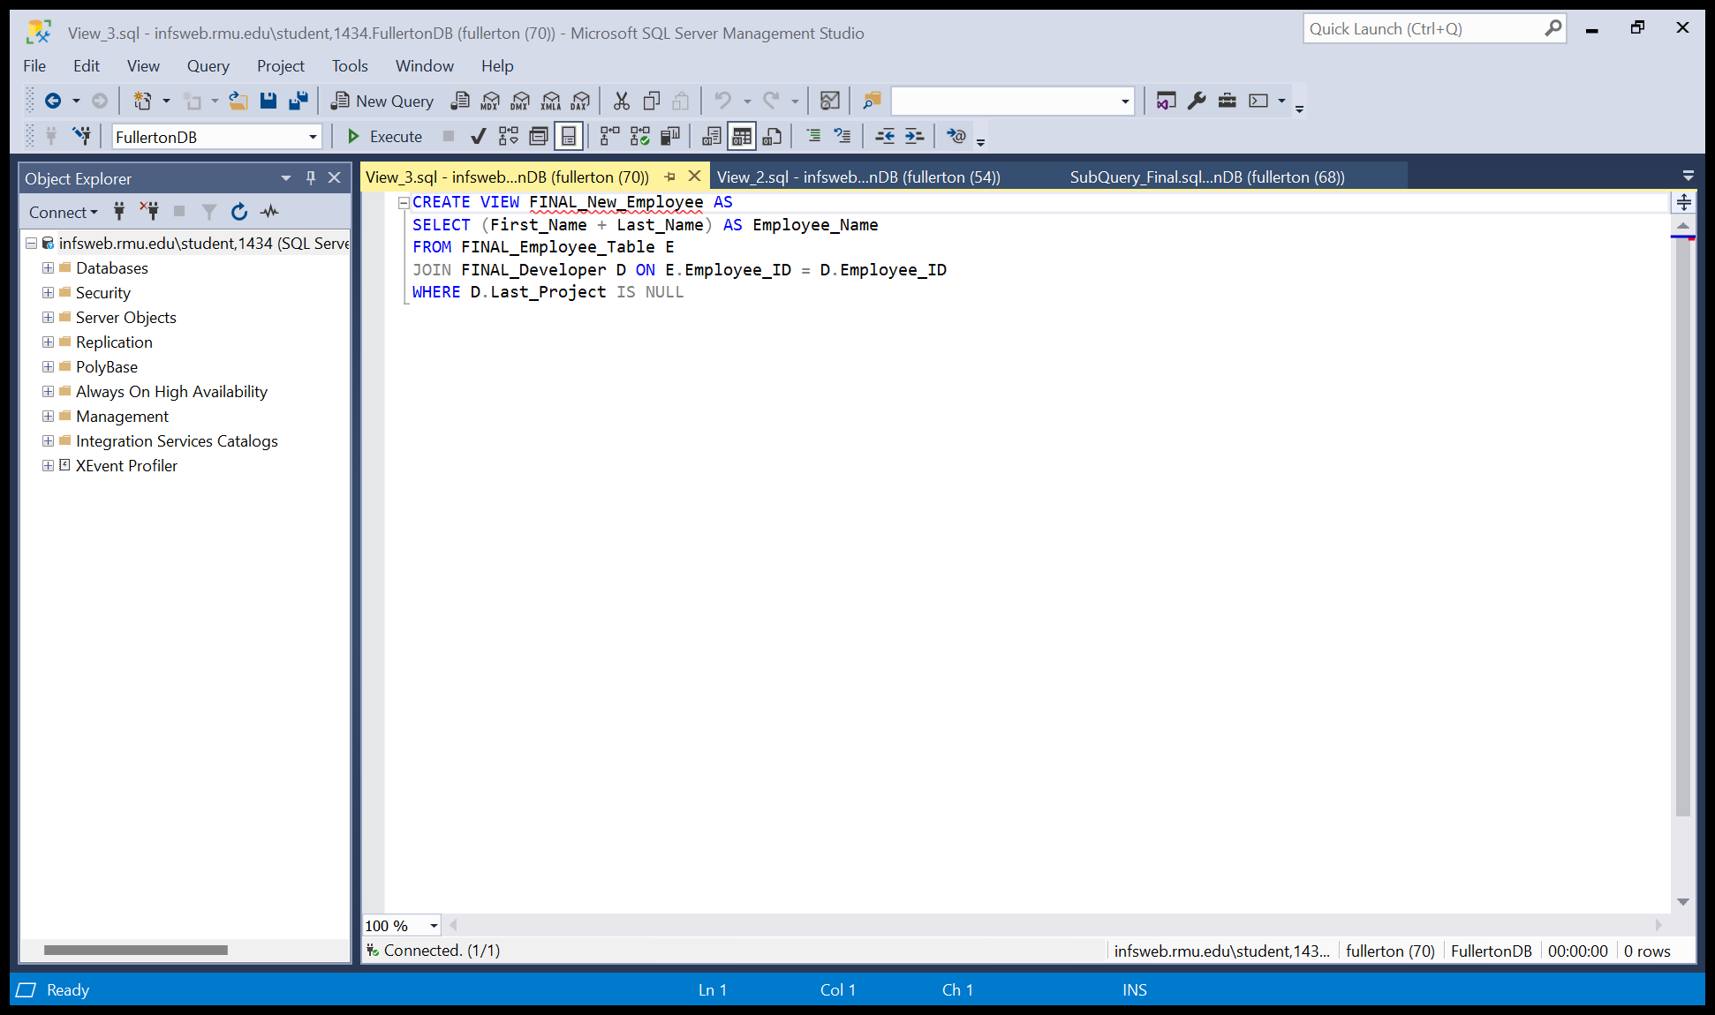

**Joins:**

**Join with Where:**

Find out if all developers working on a genre of games ae truly all on the same development team.

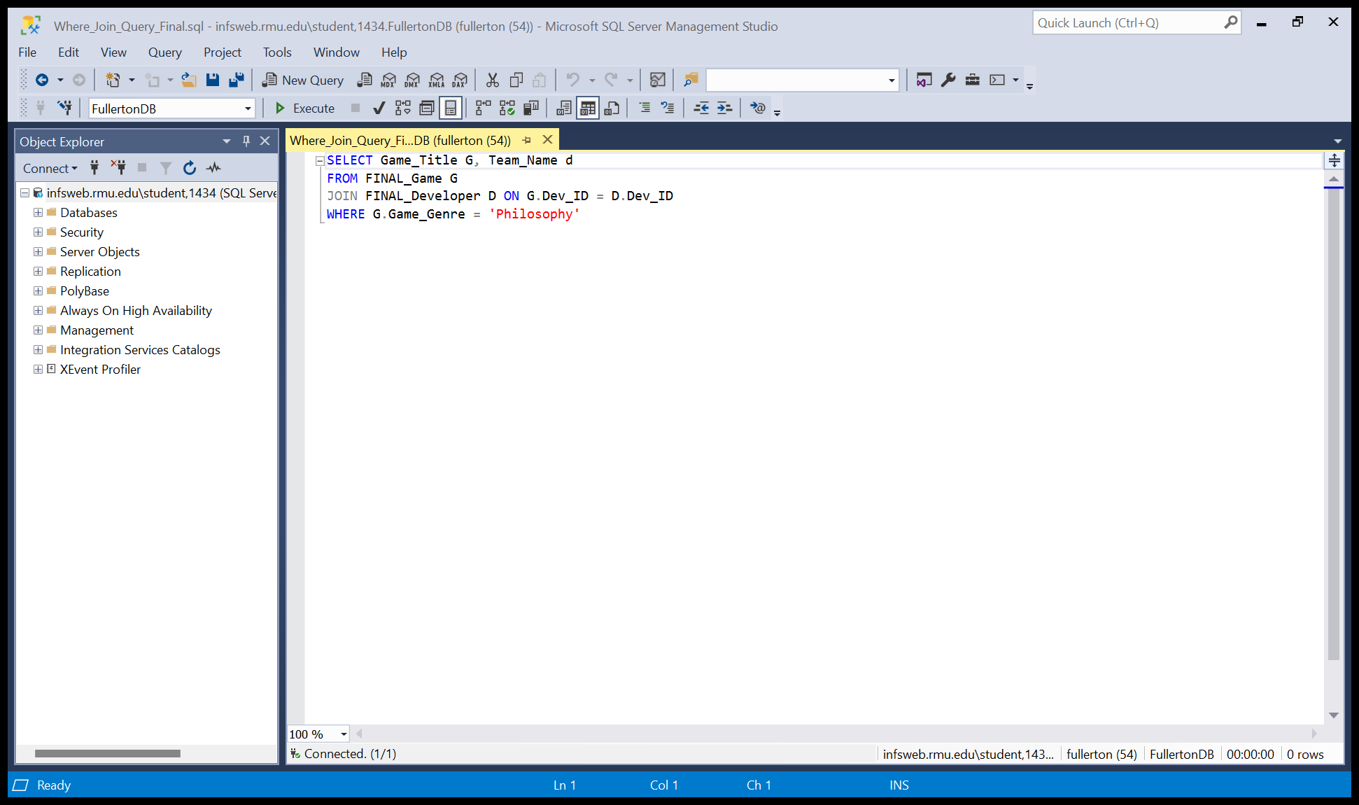

**Join with Three Tables:**

We wanted to see if we are charging too much money for our main games, and if we are, we want to know who is responsible.

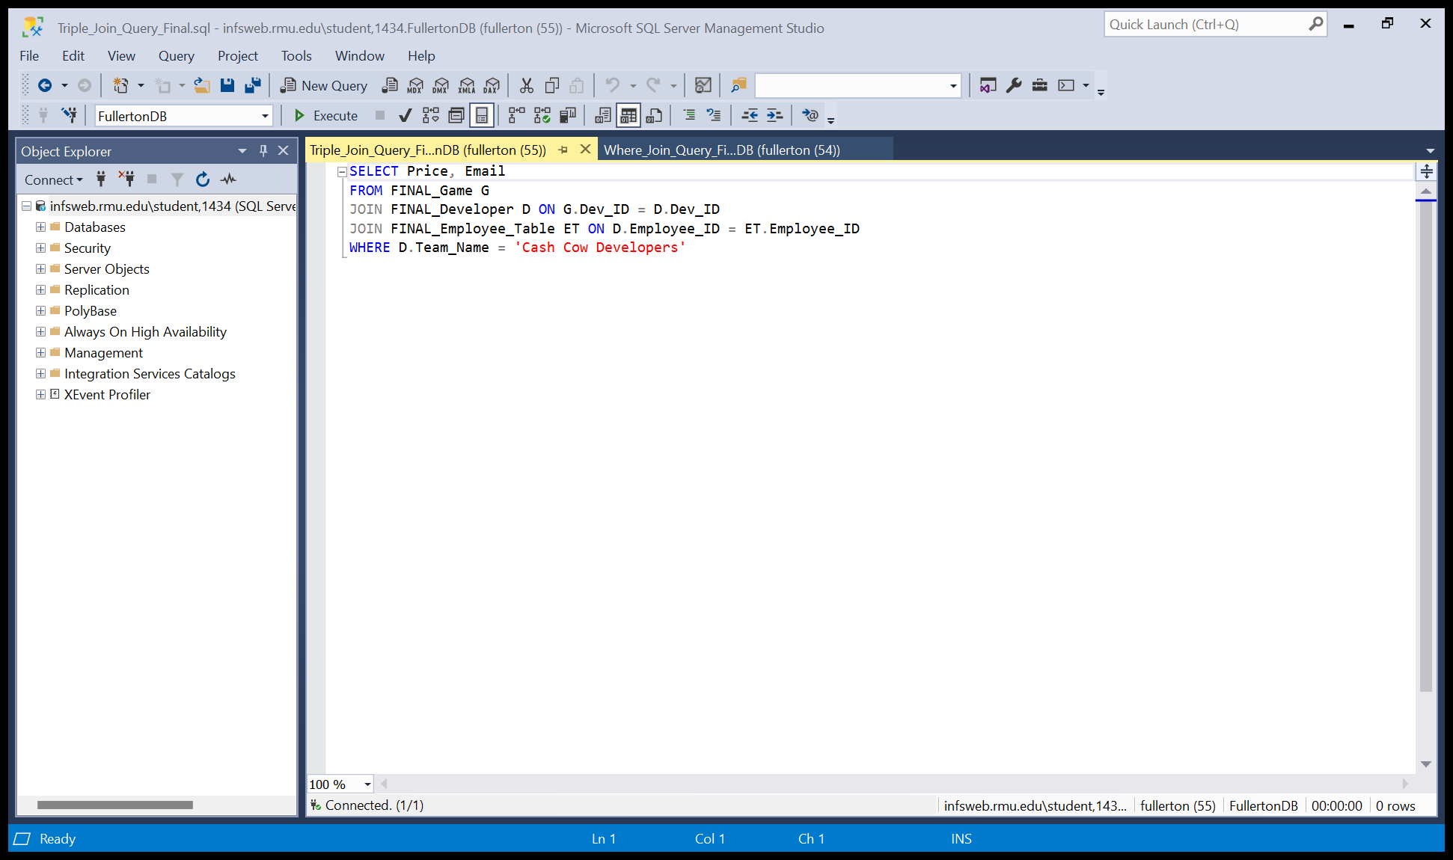

**Inner Join:**

We wanted to see exactly who was using which methods of payment for our games.

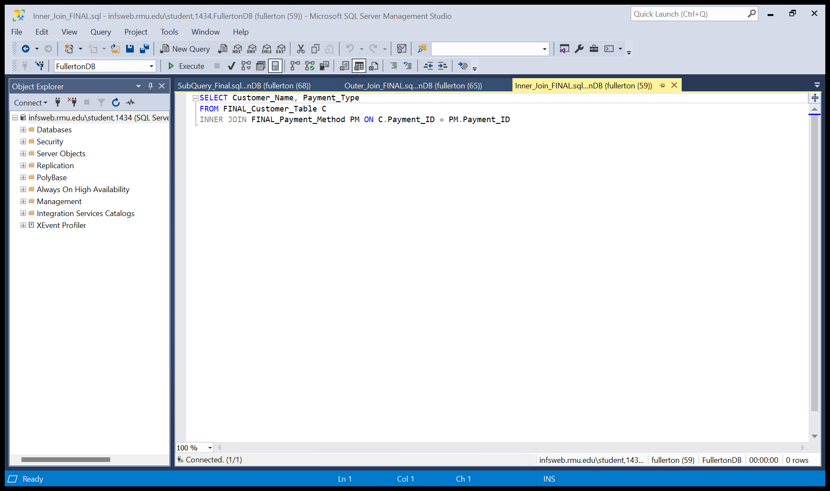

**Outer Join:**

We are going to offer an exclusive sale to all of those who have purchased a certain genre of games, in the coming year. However, we do not yet know which genre, but would still like to have all the information necessary.

